ADRIAN TURION |  | Avenue de Sainte-Clotilde 9  1205 Geneva, Switzerland | 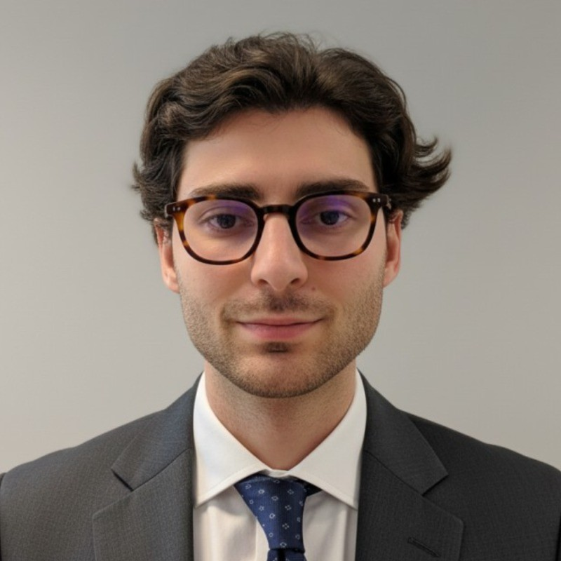
turionadrian@gmail.com | Swiss | 10.11.2000 |  | +41 77 262 37 96
INTRODUCTION
Finance graduate with M&A and financial planning experience seeking to join the EFG Graduate Programme - Corporate Functions in Geneva. Proven analytical and problem-solving skills through deal execution at a boutique advisory, financial modeling for EUR 50M mandates, and dashboard automation. International mindset developed through cross-border transactions spanning Europe, Asia, and the Americas.
WORK EXPERIENCE
Auraïa Capital Advisory – Small & Mid Cap Cross-border M&A Boutique  Mergers & Acquisitions Analyst (Converted internship into full-time position) |  | Geneva, Switzerland  Aug 2024 – Current
- Built financial models (LBO, DCF, comps, precedent transactions) for deals valued at EUR 5M-50M and prepared client presentations for Board meetings and investor pitches requiring strategic insights and analytical problem-solving skills
- Staffed on 7 live mandates spanning sell-side advisory, buy-side support, and debt advisory across healthcare, technology, and life sciences with deal values ranging from EUR 5M to EUR 50M in cross-border transactions
- Led production of marketing materials and information memoranda, maintained buyer universes of 100+ strategic acquirers, and coordinated data room management across concurrent mandates to ensure seamless transaction execution

RC Group – Currently under LBO with Crédit Mutuel Equity  Mergers & Acquisitions Intern |  | Paris, France  Feb 2024 – Aug 2024
- Worked with the CEO of Healthcare and Retail divisions on evaluating acquisition targets in France and Belgium, conducting due diligence on targets with revenues of EUR 10M-30M and preparing investment memos with market analysis, competitive positioning, and financial projections

Europ Assistance – Subsidiary of Generali Insurance  Financial Analyst Intern |  | Geneva, Switzerland  Apr 2023 – Aug 2023
- Built automated financial dashboards in Excel and PowerBI to track KPIs across 5 business units, performed variance analysis on monthly P&L results for a CHF 50M+ subsidiary, and supported the CFO on budget planning and quarterly forecasting

LEADERSHIP
- Finalist - McKinsey & Company Business Case - Presented strategic project to Keyrock management showcasing CHF 200K potential annual revenue through predictive modeling
- Associate - AIESEC Student Club - Led post-COVID recovery by closing 3 corporate partnerships generating CHF 60K annual revenue and increasing volunteer placements by 40%
- Founder - Screeny.ai - Built AI software for investment banks to identify strategic acquirers, adopted by 3 firms and reducing buyer search time by 90%
EDUCATION
HEC Lausanne  Master of Science in Finance |  | Lausanne, Switzerland  2021 – 2024
- Cumulative GPA: 5.2/6.0 (Top 15% of the class cohort)
- Exchange programs at Waseda University (Tokyo, Japan) and Maastricht University (Maastricht, Netherlands)
- Relevant Coursework: Corporate Finance, Corporate Governance and M&A, Risk Management, Valuation
- Thesis Topic: Synergies Analysis of the Merger between American Airlines & US Airways

Bachelor of Science in Management |  | 2018 – 2021
- Cumulative GPA: 4.7/6.0

Scientific Baccalaureate with Highest Honors (16.6/20) |  | Aix-en-Provence, France
ADDITIONAL INFORMATION
Languages:  Computer:  Interests:  References: | French (Native, C2), Spanish (Native, C2), English (Fluent, C1), German (Business proficient, B2-C1)  Financial Modeling | Due Diligence | Strategic Planning | Data Analysis | PowerBI  Geopolitics, Badminton (Provence regional finalist), Gym, Real use cases of Artificial Intelligence  Guillaume Arnaldez – Ex-Director at Auraïa Capital Advisory, guillaume.arnaldez@auraia.ch  Sacha Caravatti – CFO at Europ Assistance Switzerland, scaravatti@europ-assistance.ch

